# Lab 3

Eldad Kronfeld :313429607

Vlad Barkanas :317225993

## Independent work 1:

The data from the K-mean clustering to 3 clusters :

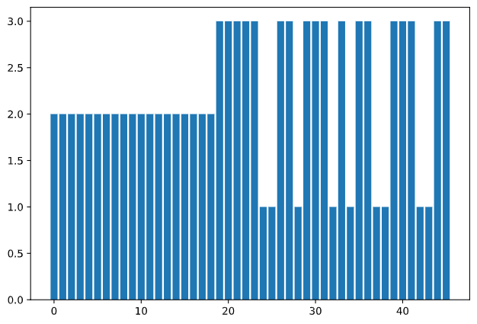

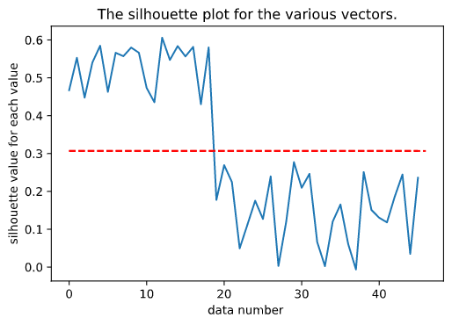

## Answer:

As we can see the average silhouette of k = 2 is around ~0.5 and for k=3 is ~0.3 and it makes sense that because we took two texts and splited them then 2 clusters would naturally cluster to 2 clusters better then two 3 clusters and it shows because the higher silhouette values.

## Independent work 2:

### K = 2

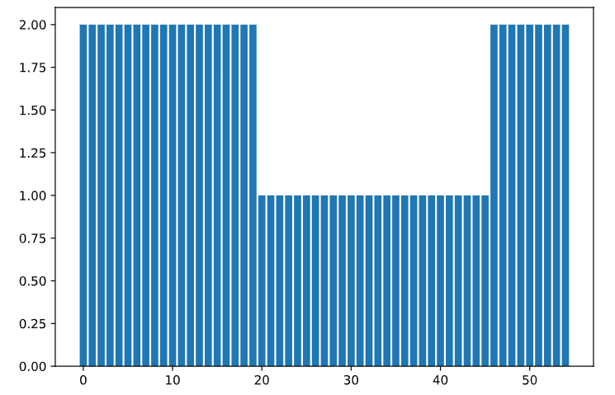

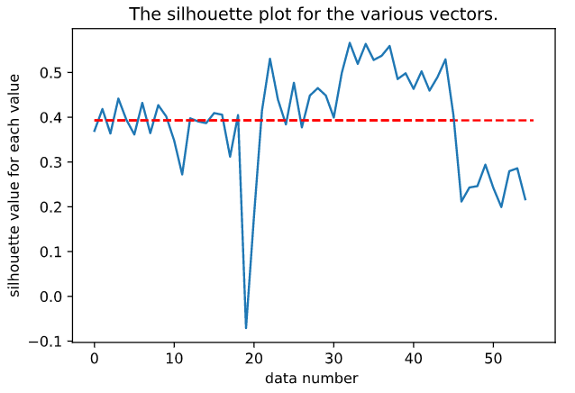

### K = 3

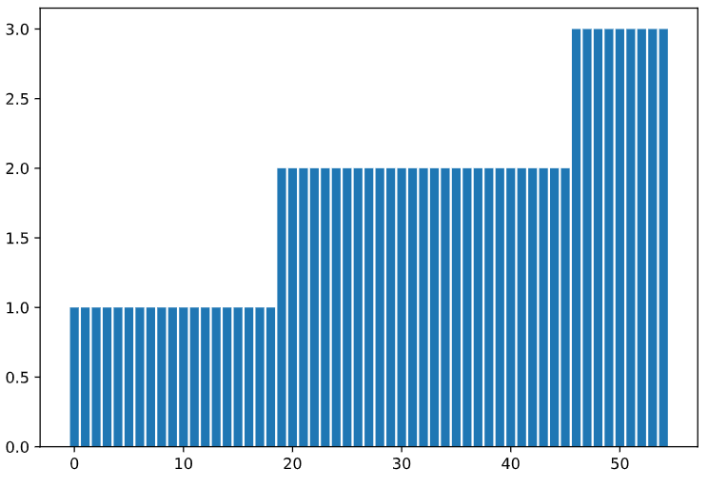

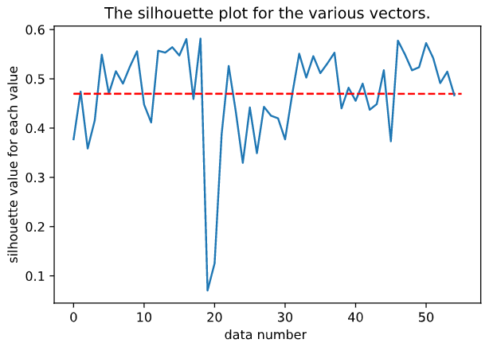

### 

### 

### 

### 

### 

### 

### 

### 

### K =4

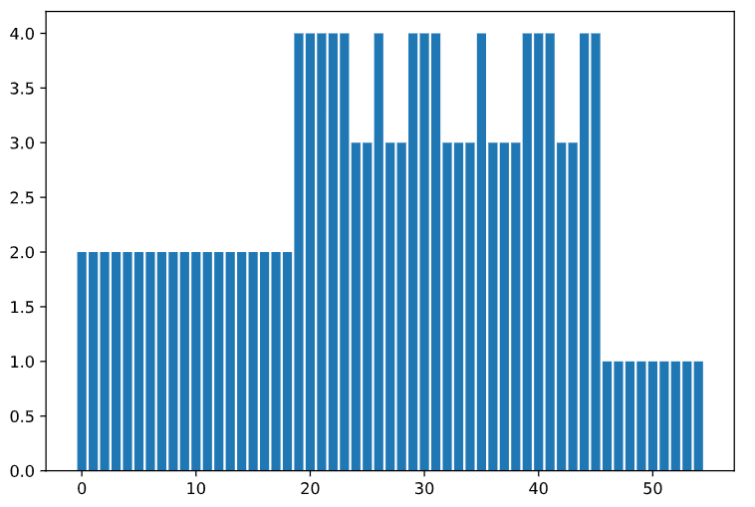

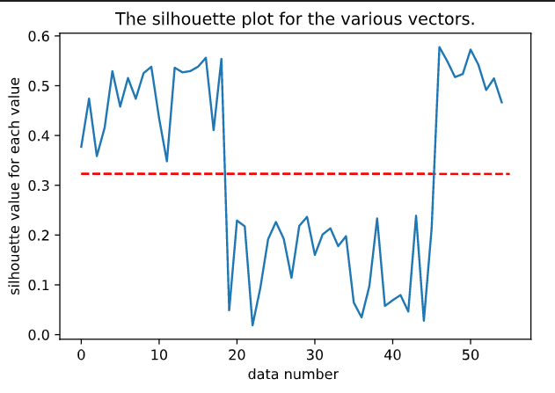

## Answer :

We can compare the average silhouette of each of K and we can see that at k=2 is 0.3930581688497115 , k=3 was 0.46958267242826374 and for k=4 we got

0.32282528052683634 and we can clearly see that k=3 was much better fit for 3 texts even if they were separated then k =2 and k = 4 .